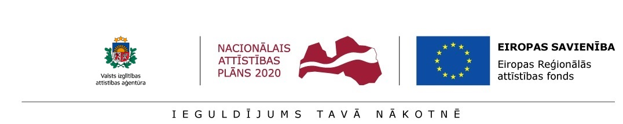

Annex 3

CERTIFICATION OF THE POST-DOCTORAL RESEARCHER

_________ __, 20__

I, ____________, ID No. _______________, the undersigned, certify that applying for support within the Activity 1.1.1.2 “Post-doctoral Research Aid” of the Specific Aid Objective 1.1.1 “To increase the research and innovative capacity of scientific institutions of Latvia and the ability to attract external financing, investing in human resources and infrastructure” of the Operational Programme “Growth and Employment”:
- I have not previously received support within the scope the Activity 1.1.1.2 “Post-doctoral Research Aid” of the Specific Aid Objective 1.1.1 “To increase the research and innovative capacity of scientific institutions of Latvia and the ability to attract external financing, investing in human resources and infrastructure” of the Operational Programme “Growth and Employment”;
- In case of granting support for this research application I will not receive remuneration concurrently within the scope of this Activity as well as within the scope of Activity 1.1.1.1 “Practical Research Aid” and Activity 1.1.1.3 “Innovation Grants to Students” of the Specific Aid Objective 1.1.1 “To increase the research and innovative capacity of scientific institutions of Latvia and the ability to attract external financing, investing in human resources and infrastructure” of the Priority Action “Research, Technology Development and Innovations” of the Operational Programme “Growth and Employment”.

__________________
(signature)

