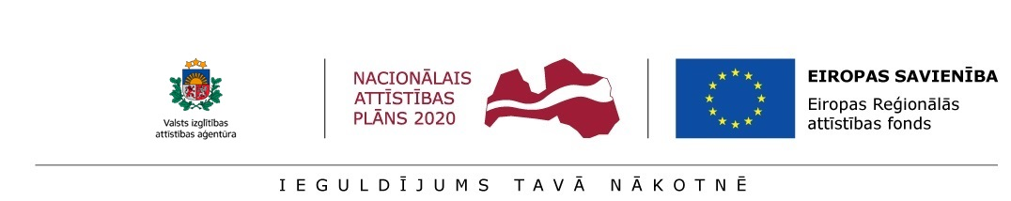

Annex 1

APPLICATION
for preliminary selection of post-doctoral applications
at the Latvian Institute of Organic Synthesis

for the submission of research application selection round within the scope of the Activity 1.1.1.2 “Post-doctoral Research Aid” of the Specific Aid Objective 1.1.1 “To increase the research and innovative capacity of scientific institutions of Latvia and the ability to attract external financing, investing in human resources and infrastructure” of the Operational Programme “Growth and Employment”

Surname | Name
e-mail address / phone
Citizenship / Current place of residence

For communication with me and notification of the results within this pre-selection,
please use: __________________________________________________________________
/ indicate the type of communication and contact details /

Applicant's name, surname
Title of the research application
Person responsible for the research of the research application (scientific/commercial consultant)
Scientific sector/s, sub-sector/s of the research theme
Research application type:
(related or not related to economic activity)

Documents attached: | Research Project Proposal in English (Form - Annex 2 to the Regulations)
 | CV in English (Europass)
 | A copy of the diploma of the doctoral degree.
 | Certification of the post-doctoral researcher (Form - Annex 3 to the Regulations)
 | Information about the readiness of the cooperation partner to participate in research application implementation (if applicable)
 | Information about the potential consultant from the sector of science or national economy (CV)
 | Other documents certifying the post-doctoral researcher’s skills, knowledge and capacity (if applicable)
Documents attached by a foreign post-doctoral researcher on a project, which was submitted in collaboration with the Latvian Institute of Organic Synthesis for the Marie Skłodowska-Curie action “Individual Fellowships” of the EU Framework Programme for Research and Innovation “Horizon 2020” and was evaluated above the quality threshold in the abovementioned evaluation of project applications, however, did not receive funding for project implementation | Assessment of the scientific quality of the project provided by experts included in the European Commission expert database
 | The European Commission's decision on approval of the project
 | A copy of the Project application submitted within the frame of the Marie Skłodowska-Curie action “Individual Fellowships” of the EU Framework Programme for Research and Innovation “Horizon 2020”

Post-doctoral researcher: ____________________ /__________________/ ____._____. 20____
signature name, surname

* Documents are received by the Latvian Institute of Organic Synthesis on:

______________ _____, 20___ _____________________ /__________________/
signature name, surname

Notes:
1. * marked sections are filled in by the project administration.
2. The data indicated in the application will only be used by the Latvian Institute of Organic Synthesis only for the administration of the research application.

